**How do I migrate an existing WordPress app to Azure Web App for Containers in Linux?**

**Prerequisites**

* An Azure WordPress on Linux App Service to serve as a destination.
* A Source Linux WordPress installation needing migration. You will need administrative access to the site files and MySQL database.
* MySQL Database Requirements:
  + Azure Database for MySQL currently only supports versions 5.6.3.5 and 5.7.1.8 using the InnoDB engine.
  + If you have MyISAM tables, convert them to InnoDB before migration. For more information, see the MySQL article [Converting Tables from MyISAM to InnoDB.](https://dev.mysql.com/doc/refman/5.6/en/converting-tables-to-innodb.html)

# **Overview**

* The two key components of your WordPress site are the Site Files and MySQL database. In this scenario we will move the Site Files and Database from your existing installation to the Azure App Service.
* We have a basic WordPress site configured on a Linux Virtual Machine. We have posts, theme, and media which need to be migrated.

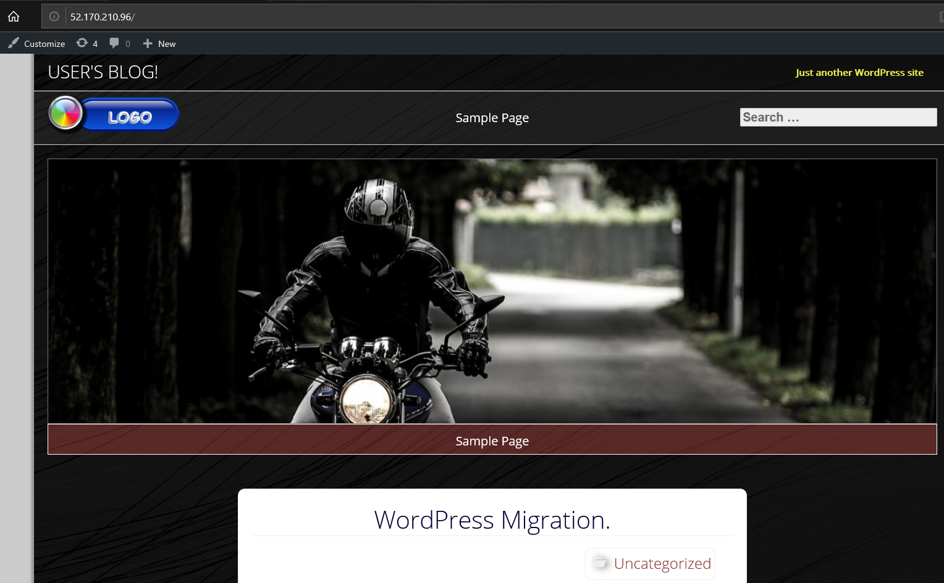

**Migrate your site files**

###### Download your Site files from your source server.

1. Connect to your existing server. We are using FTP with the FileZilla client. You may have different tools available depending on your hosting provider.
2. Identify your WordPress site directory. This will contain your WP-Content folder, and WP-Config.php. In our case the location is “/opt/bitnami/apps/wordpress/htdocs” .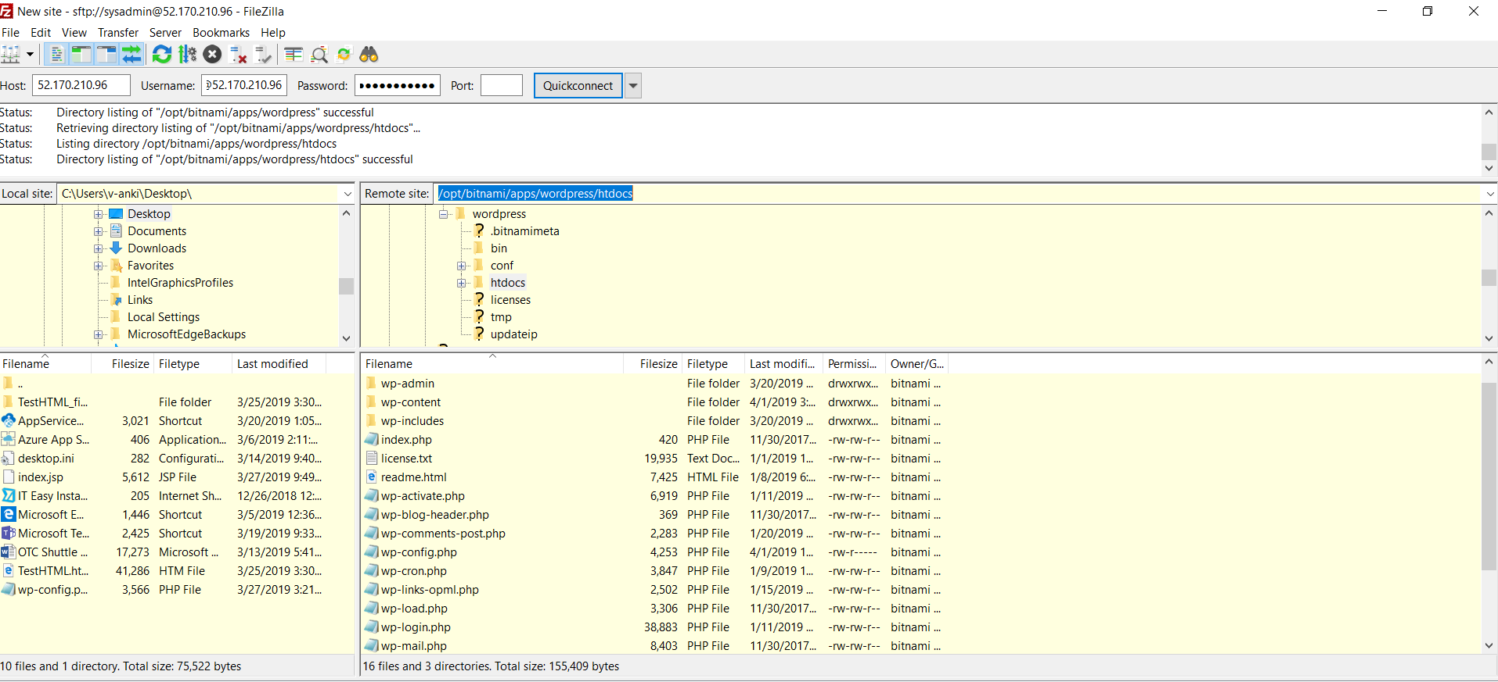
3. Download the root directory. This may take some time.
4. Once the download has completed. Find the WP-Config file. Append the filename with .OLD. (Note: The Web app generates a WP-Config populated with the necessary database connection settings. This should work for most situations but you may want to retain your old config file for future reference.)

Upload your Site files to your destination App Service.

1. Find the **FTPS Hostname** URL and **FTP/Deployment Username** in the App service overview. (If you have not created deployment credentials, or need to reset the password Click the **Deployment Credentials** blade on the left to do this)

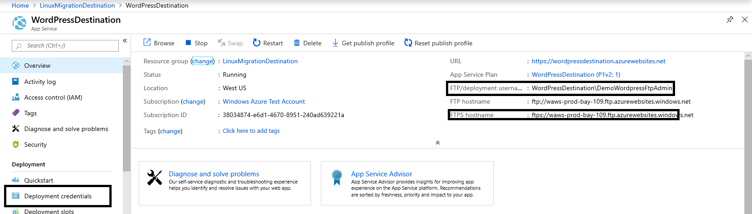

1. Use an FTP client to connect to the Azure App service site with by entering:
   1. The FTPS URL into the hostname field.
   2. The Deployment Username into the username field.
   3. The Deployment Username password into the password field.
   4. Connect, there may be certificate warning. Click OK.

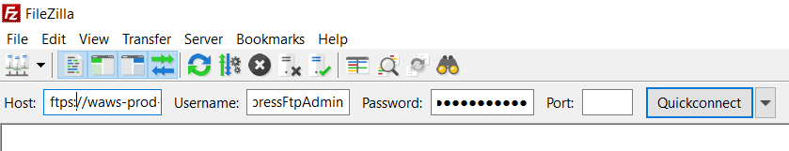

1. The directory structure will look like the screenshot below.

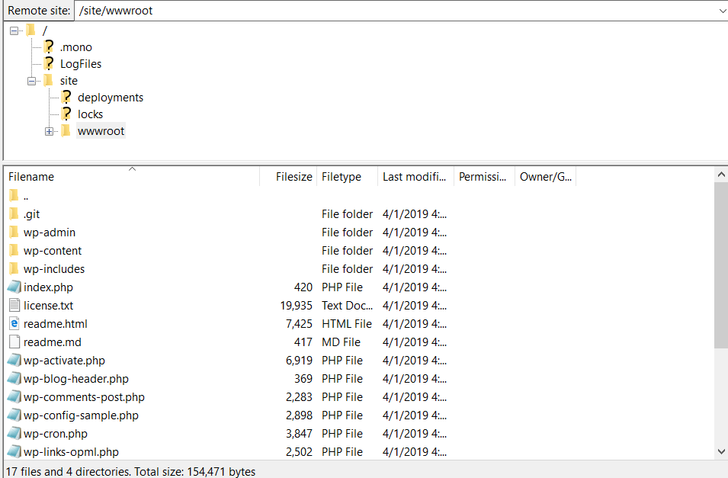

1. Locate the /site/wwwroot/ directory.
2. Open the directory you exported from your source site.

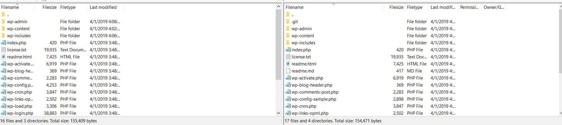

1. Select all your files and upload to Azure web app using FTP. When prompted select Overwrite to replace the files in the destination. Select “Always use this action”, Then click OK.

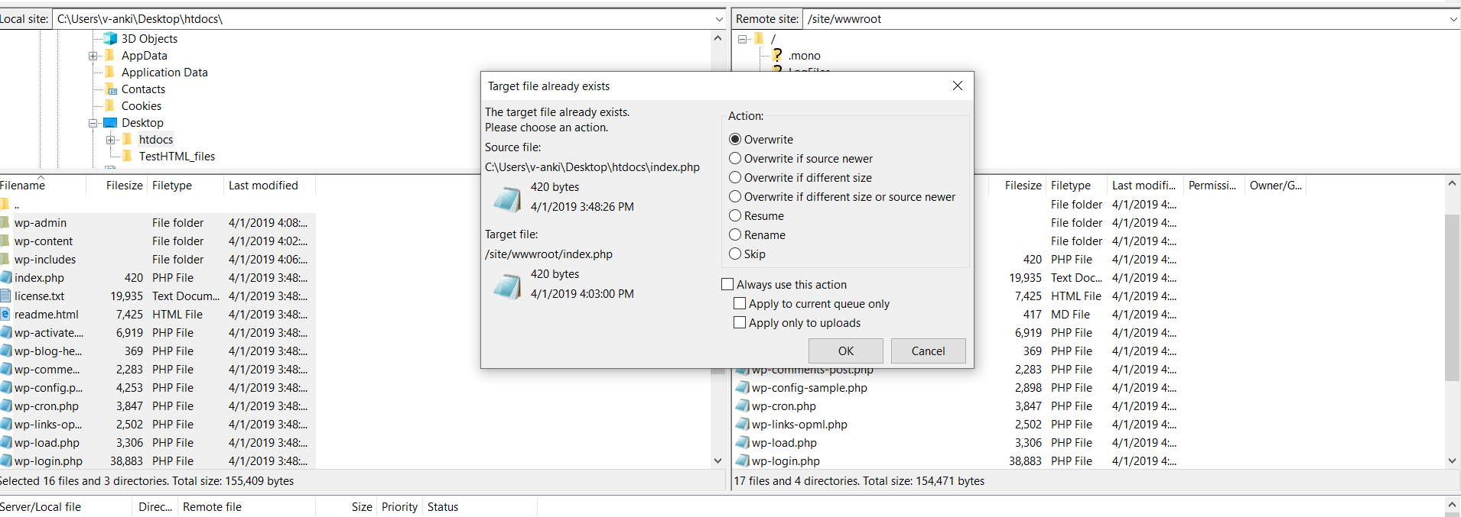

1. The file upload will begin. This may take some time.

**Backup the MySQL WordPress Database.**

* For this step we will need MySQL Workbench on your workstation. You will also need a login credential and network access to your MySQL server on port 3306.
* If you do not already have MySQL Workbench it can be downloaded from. <https://dev.mysql.com/downloads/workbench/>

1. Open MySQL Workbench and click the **+** icon next to the MySQL connection.

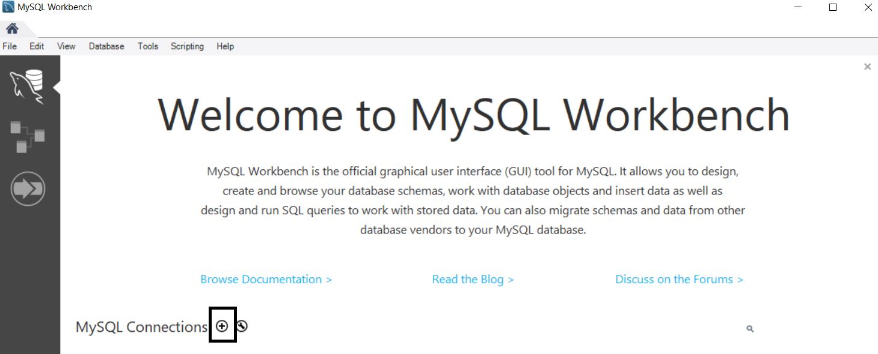

1. Then enter the connection information. Typically, the IP address/hostname of the server running MySQL can be used (Localhost if running locally). The username needs to be a user with access to the WordPress database remote remotely. Note: the root user may be restricted from remote login.

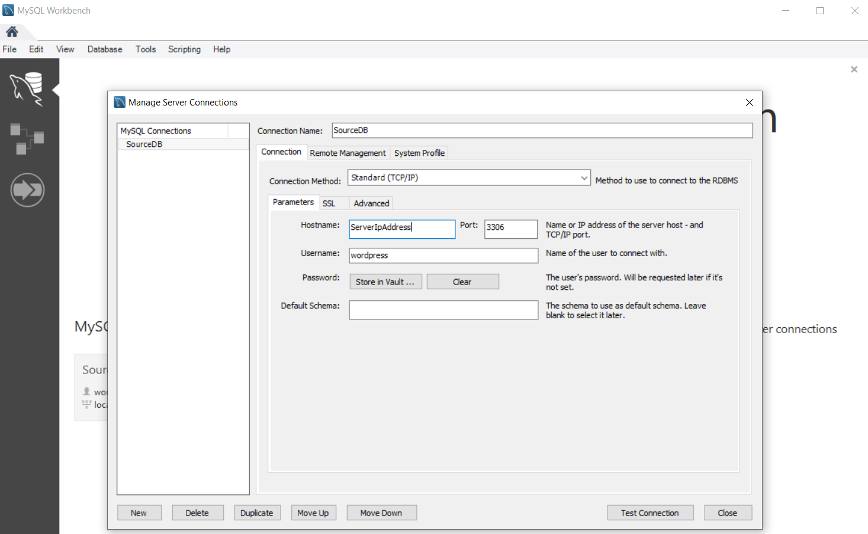

1. Once you have connected click **Data Export** to start exporting your WordPress database. In our case the WordPress Database Name is bitnami_wordpress.

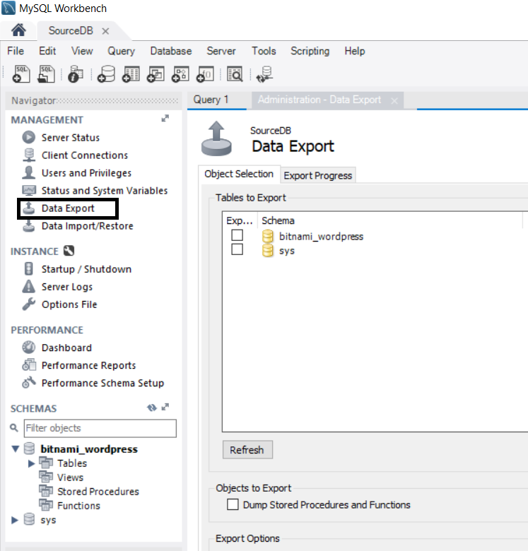

1. Specify target directory on Export Options. You need write permissions in the directory to which you are writing the backup. (All other options can be left at default)
2. Click Start Export on the lower right of the window.

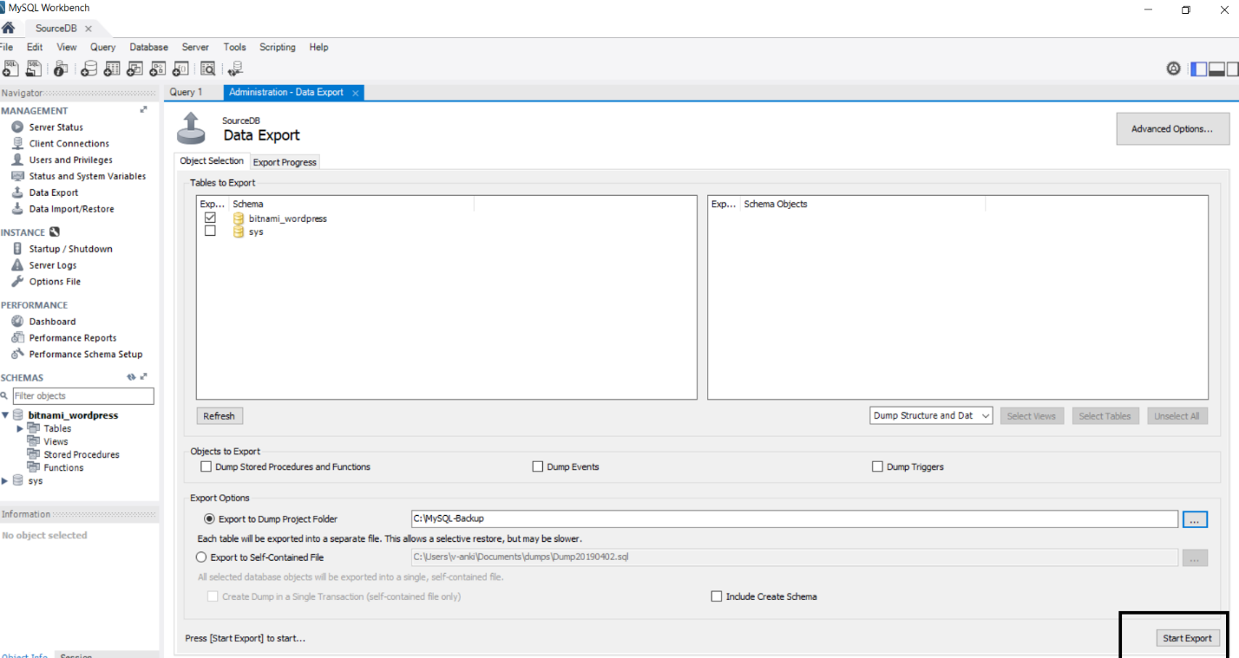

1. The export process will begin. Once Complete you should see a screen like this.

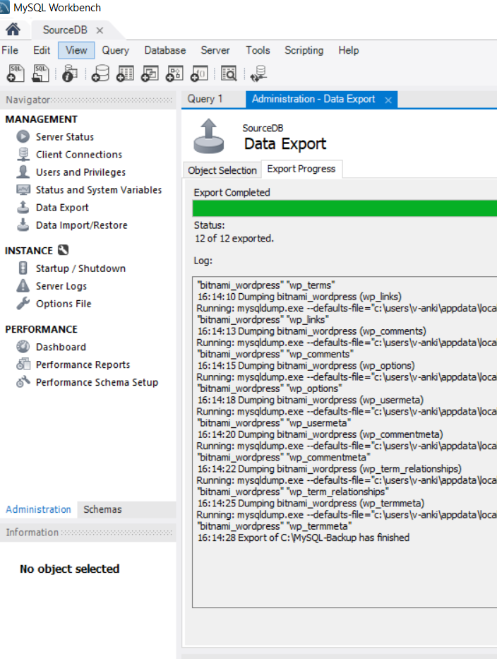

**Import the database into your Azure WordPress on Linux App Service**

* In this step we will import the exported data into the Azure MySQL instance using MySQL Workbench.

1. We will first need to gather the connection info for your Azure MySQL database. This can be found by navigating to your web app in the Azure portal, then navigating to **Configuration** then find **Application Settings** tab at the top. Click the **Show Values** button to make the values visible. Leave this window open as this information will be needed again in a later step.

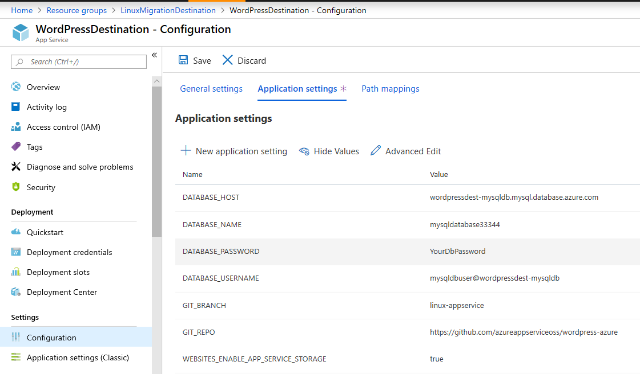

1. Return to your MySQL Workbench. Click the **+** to open a new connection. Then enter the information from the **Application Settings** tab. Click **Store In Vault** to enter the password

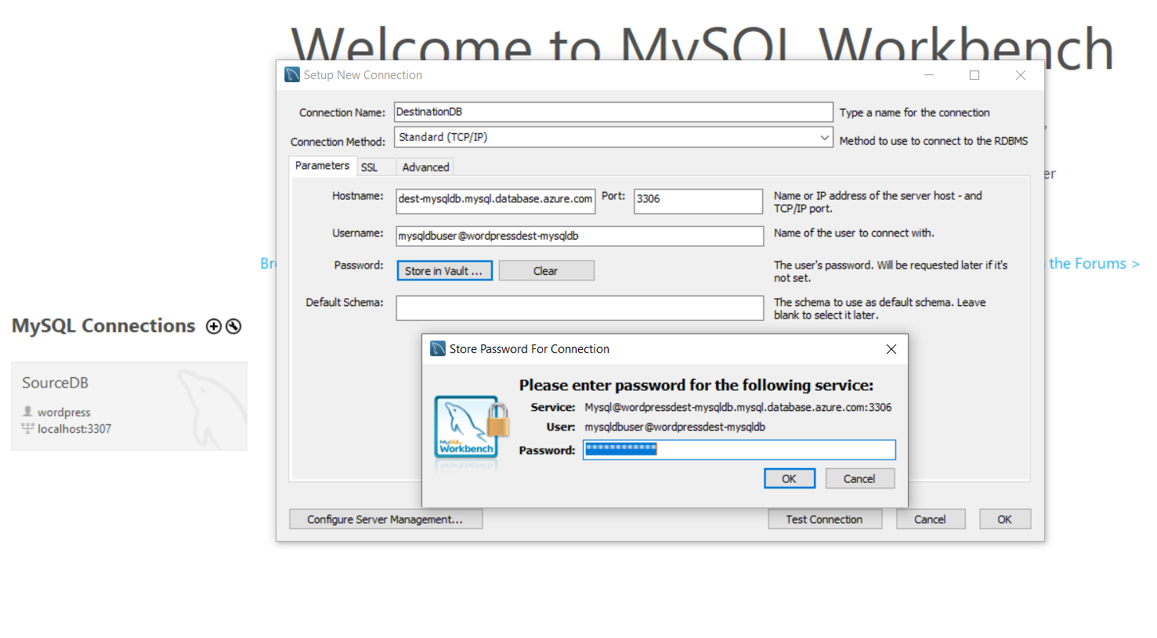

1. Once the information is entered click **ok.**
2. The connection will appear under **MySQL Connections**. Click the connection to start.

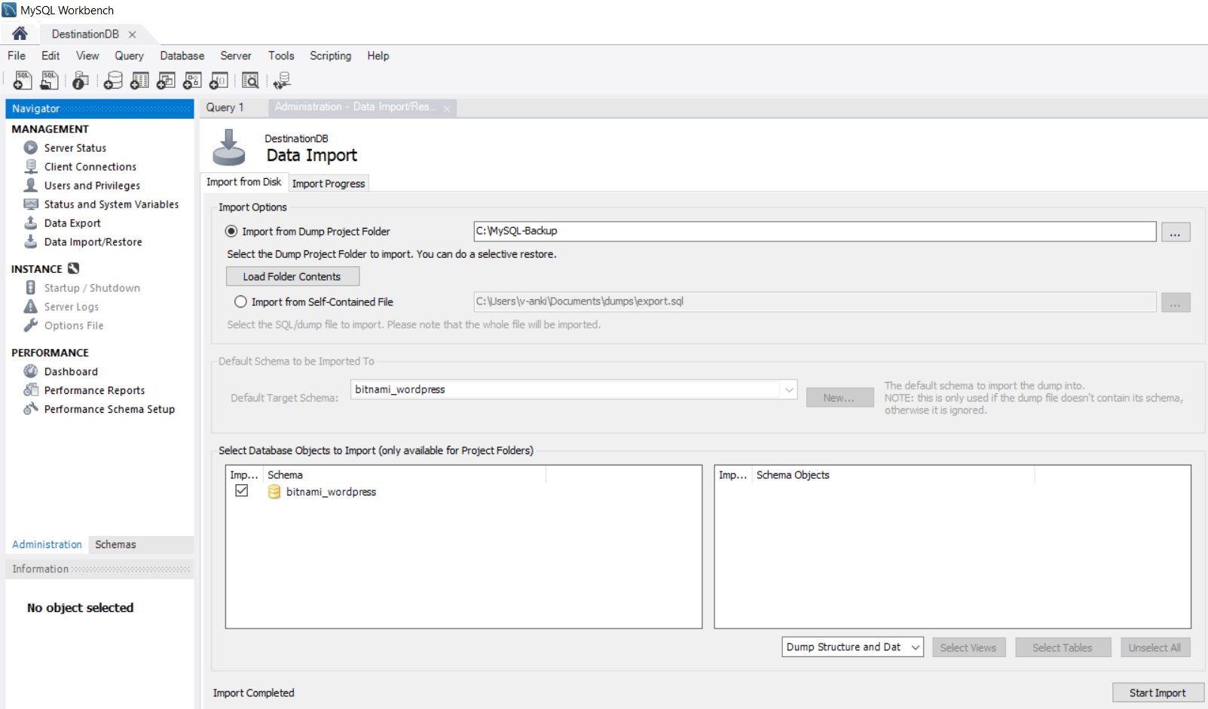

1. Click **Data Import/Restore** on the left.
2. Click the **… to** the right of **Import from Dump Project Folder**. This will be the folder where we exported the files from your source server.Enter the same database name as your source. This creates
3. To the right of **Default Target Schema** (Note: MySQL Workbench refers to Databases as schemas)click **New.** The database name should be identical to the database name on your source server
4. Click **Start Import** to import the Database.
5. Once the import completes click **Schemas** from the lower left hand. This will display the current Databases.

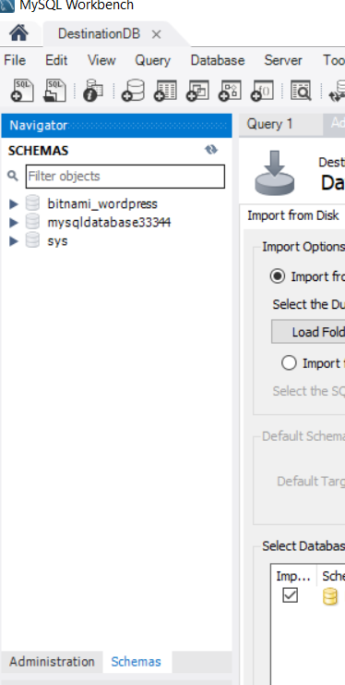

1. You will see the database you imported. You may now delete the existing MySQL database by right clicking and selecting **Drop Schema** (Note: Do Not delete the SYS database)
2. In the Azure Portal return to **Application Settings.** Set the **DATABASE_NAME** to match the imported database.

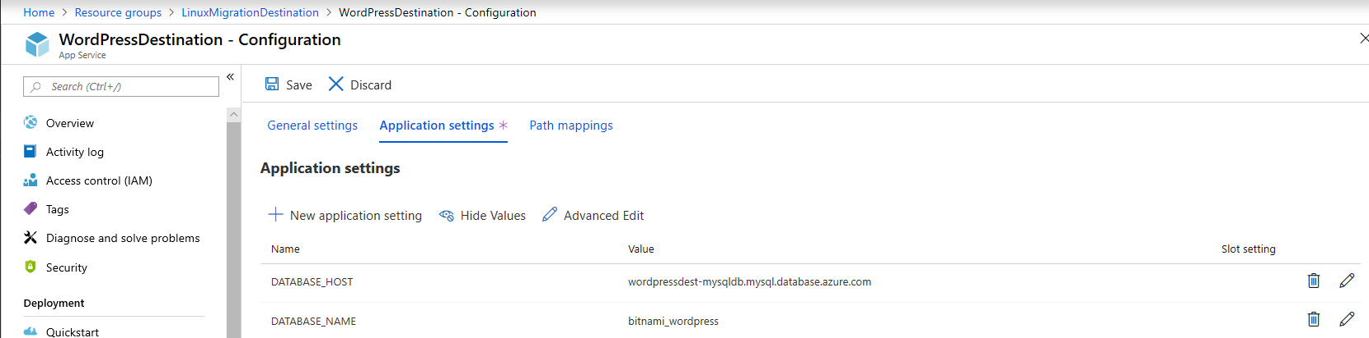

**Verify Site**

* You can test the functionality of your new website by clicking the **Browse** button

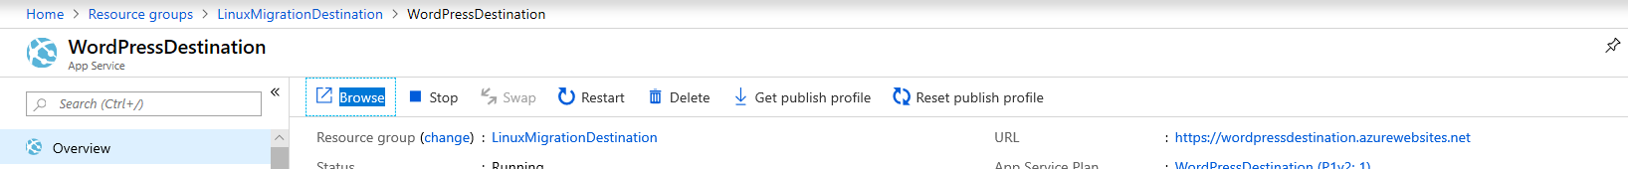

* Your WordPress site, content, themes and media will now be present at the URL.

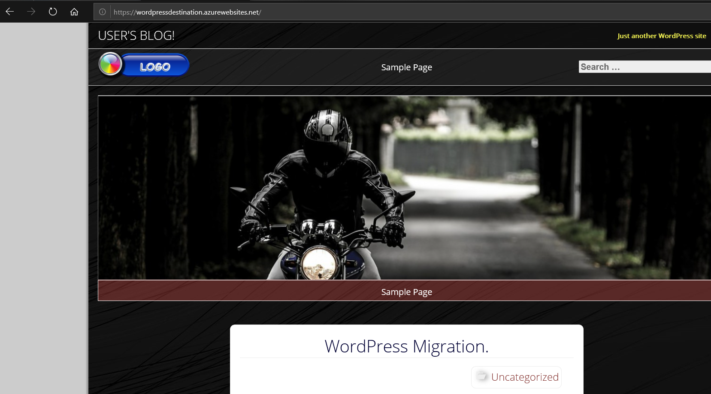

**Next Steps**

* [Buy and configure an SSL certificate for Azure App Service](https://docs.microsoft.com/en-us/azure/app-service/web-sites-purchase-ssl-web-site)
* [Buy a custom domain name for Azure App Service](https://docs.microsoft.com/en-us/azure/app-service/manage-custom-dns-buy-domain)